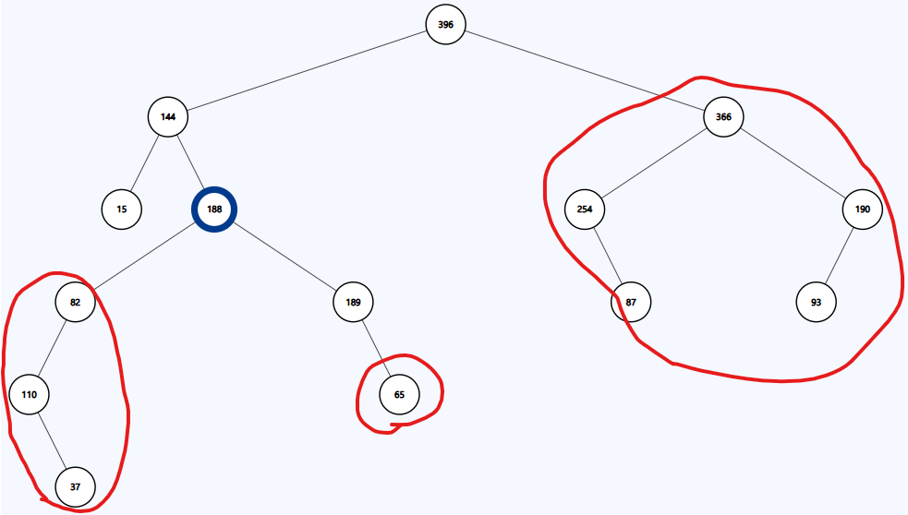
2. BST Traversal
PreOrder
Not a BST, not an AVL.

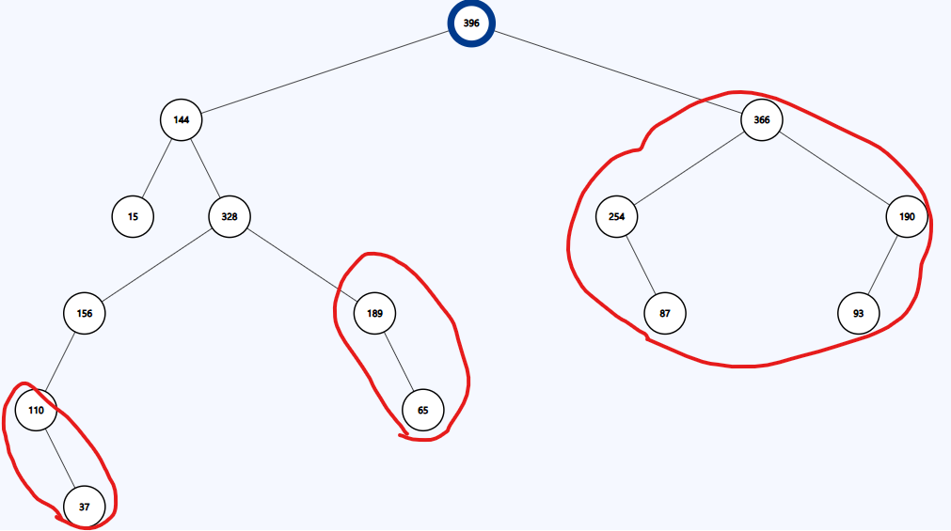
InOrder
Not a BST, not an AVL.

